3 Stop Time
Start time + 5m / speed of light = start time + 16.667 ns
Stop time = 30 ns or 30,000 ps

7b Plot
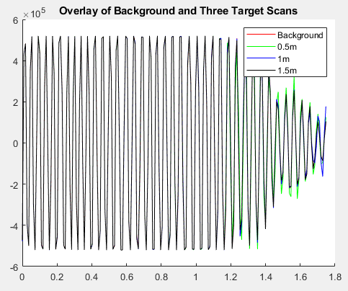

7c Difference Plots
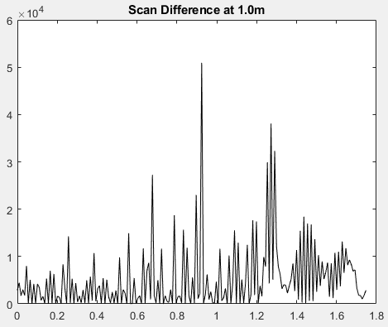
The 1m graph shows noise before the target value at approximately 0.9m. This noise is likely from my labmate’s chair. The value at about 1.3m is likely the table in the middle of the lab.

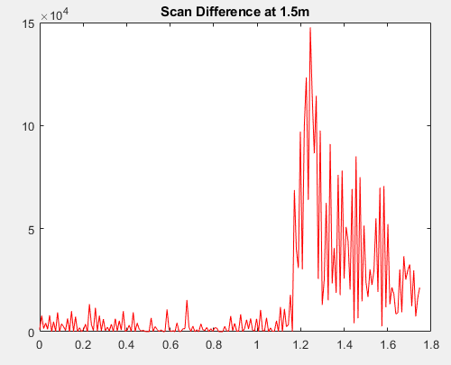
The 1.5 m graph shows the target at approximately 1.3 meters. The noise following the target is likely the table in the middle of the lab and the various items on it.

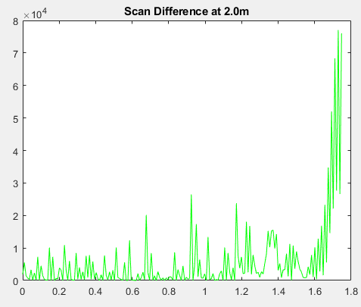
The 2m graph shows the target at approximately 1.7m. The noise before the target is likely a combination of chairs and other objects in the way of the radar.

8 Power Calculations and Graph
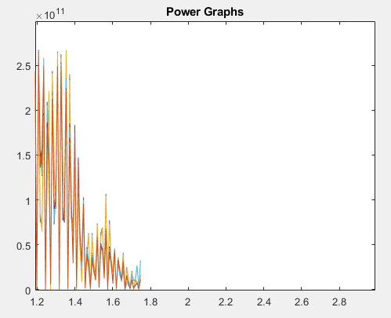
The power calculations follow the expected 1/R^4 decay relatively well. The starting values hold at a constant power before starting the decay, but once the decay starts the graph follows the expected results.

9 Power Graph
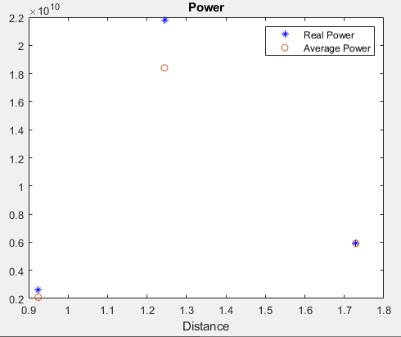
The average received powers for the 1m and 2m scans follow the predicted performance very well. The average received power for the 1.5 meter scan, however, deviates significantly from the expected value. This is likely due to the table in the middle of the lab and the various objects around it reflecting the transmitted signal, causing interference and additional reflections that affect the measured received power.

All 4 objects used in part 10 were placed approximately 1 meter from the radar.
10 Large Sphere
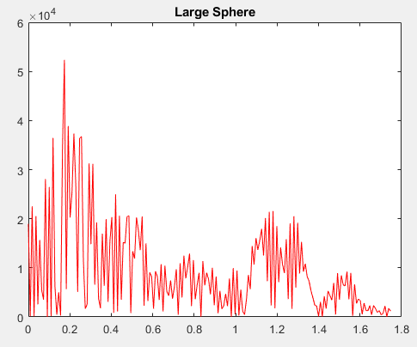
This data is very noisy between 0 and 1 meters. The peak at 0.2 meters is likely my labmate or his chair. I do not know what the other peaks before 1 meter are, though they are likely a combination of my labmates and things on their tables. The peak at approximately 1.2 meters corresponds to the target.
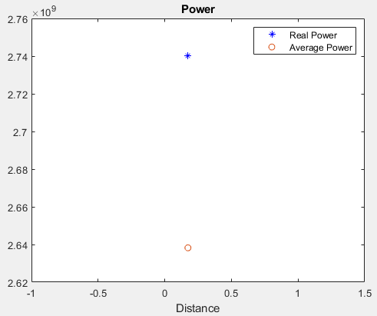
The power of the large sphere seems to be vastly different from the expected value, but I doubt this is the case. The power most likely differs so dramatically because the signal used to calculate the power is noisy.

10 Small Sphere
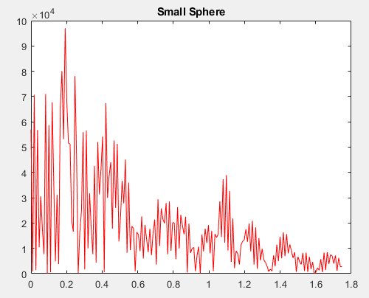
The small sphere graph is noisier than the large sphere graph. The spike at 0.2 meters is likely my labmate or his chair. The other peaks before 1 meter are likely a combination of my labmates and things on their tables.The spike at about 1.1 meters is the target.
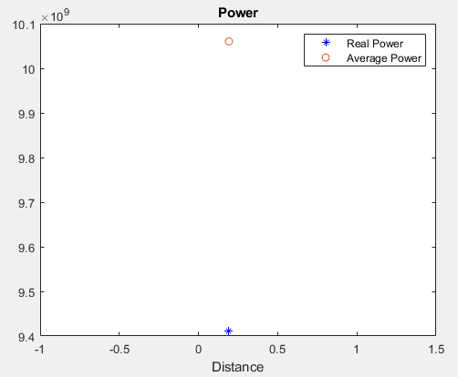
The signal power graph again shows a discrepancy between real power and the expected value. This is expected. The small sphere has less surface area, and therefore should have less signal power than the large sphere and the expected value.

10 Plate
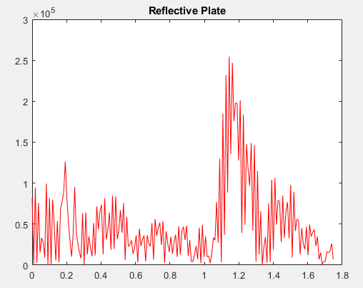
This is by far my cleanest scan of the lab so far. There is very little noise present relative to my other scans. The peaks at and around 0.2 to 0.5 meters are likely my labmate and his chair. The peak at about 1.35 meters corresponds to the reflective plate. The noise beyond the plate is Zach (who held the plate for me) leaning down and away from the plate.
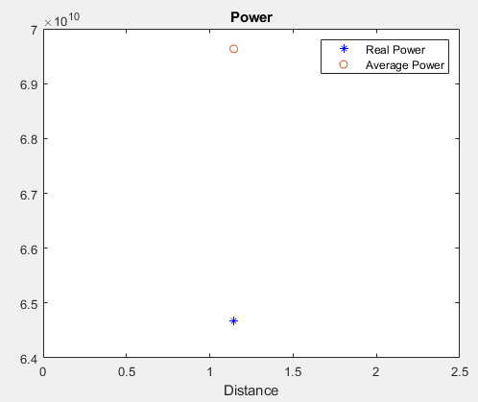
The power of the reflective plate is high relative to the other objects. In fact, it has the highest power out of all 4 targets. This is to be expected as the reflective plate has a high surface area relative to the other targets, meaning the radar has more reflections to pick up on.
10 Person
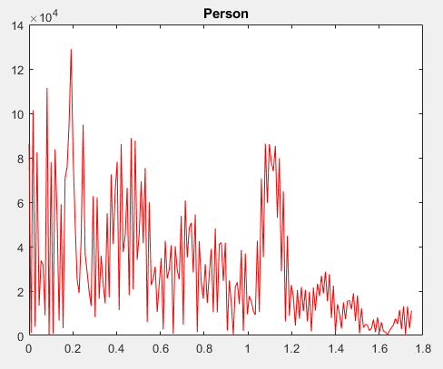
The noise at 0.2 and 0.4 meters likely correspond to my labmate and his chair. I do not know what the peak at about 0.7 meters could correspond to. The peak at 1.1 meters is Zach, who stood in front of the radar for this scan.
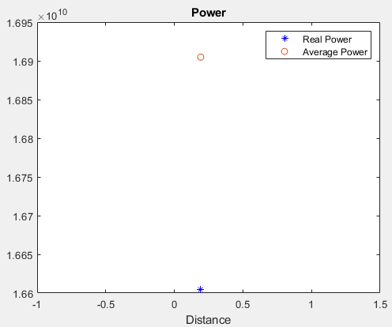
The real and average power are very close. This makes sense as the human target has by far the largest surface area of any target used.
Questions
- The received signal power plots followed the 1/R^4 prediction well, but not exactly. Small deviations were likely caused by environmental interference, reflections from nearby objects, and measurement noise. These results could be improved by reducing nearby obstructions, taking multiple measurements at each distance and averaging them, and keeping the transmitter and receiver properly aligned throughout the experiment.
- At one meter, the received signal power was 2.64 x 10^9. Using the 1/R^4 relationship, the predicted received signal power at 10 m would be 2.64 x 10^5, and at 30 m it would be approximately 3.26 x 10^3. The received signal power could be increased by reducing the distance between the transmitter and receiver, increasing the transmitted power, or using higher-gain antennas.
- The signal powers were all within an order of magnitude of each other. The large sphere and plate would be expected to reflect more signal due to their larger surface areas, while the small sphere would likely reflect less. The person’s received signal power could vary depending on body orientation and the amount of signal absorbed by the body. Overall, the results were reasonably expected, although differences in target shape, material, and orientation likely contributed to variations in the measured signal powers.

